IRCTC Application – UI Design

# **Screen Mockups**

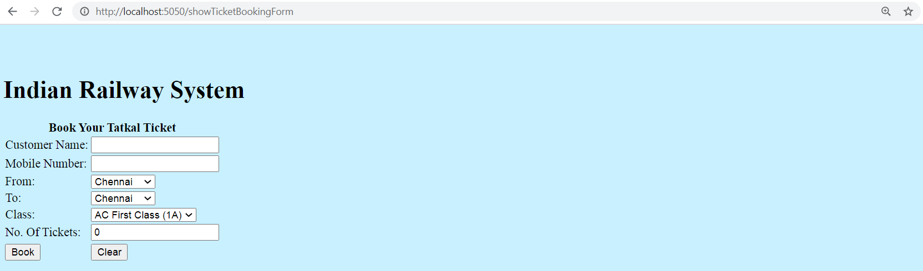

**Screen 1 – Home Page**

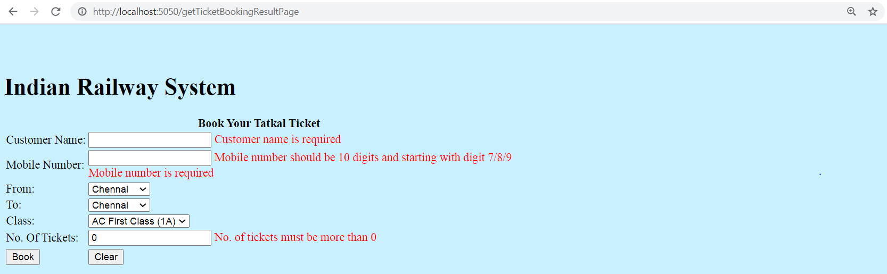

**Screen 2.1 – Home Page with Validation Error Messages**

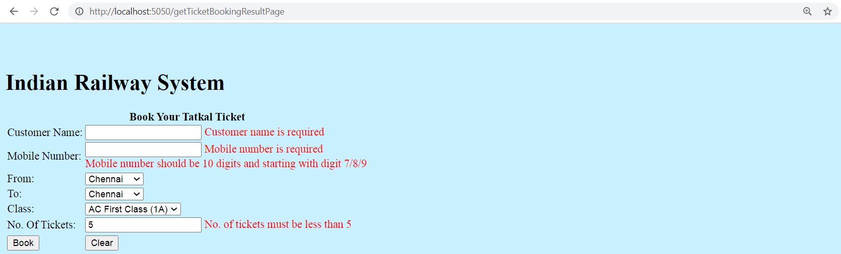

**Screen 2.2 – Home Page with Validation Error Messages**

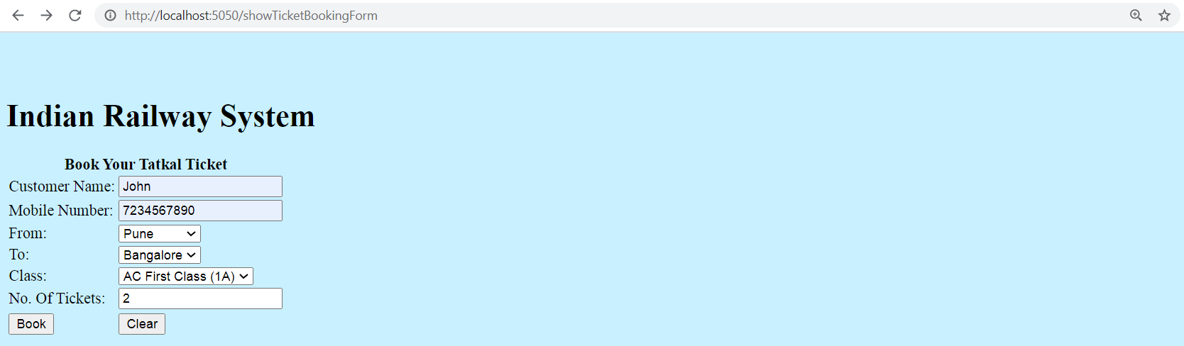

**Screen 3 – Ticket booking form with values**

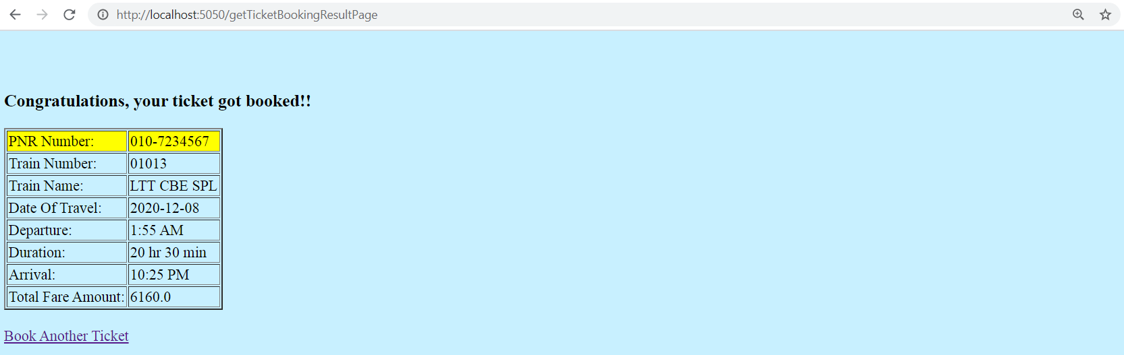

**Screen 4 – Results Page showing booked ticket details**

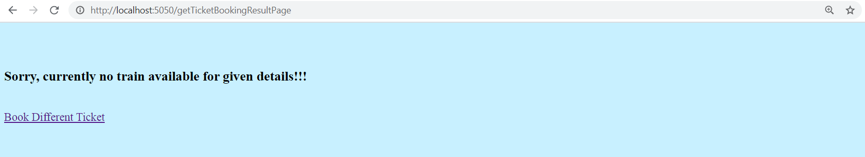

**Screen 5 – Results page showing message if train is not available as per search criteria**

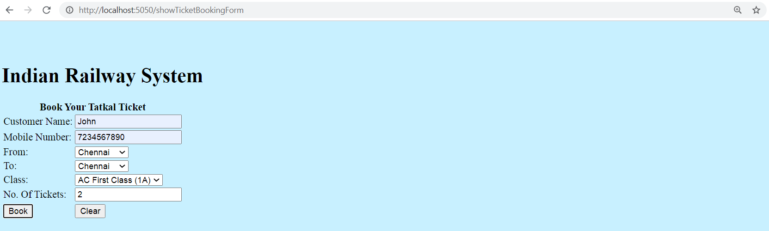

**Screen 6 – Ticket booking page where from and to city is selected same**

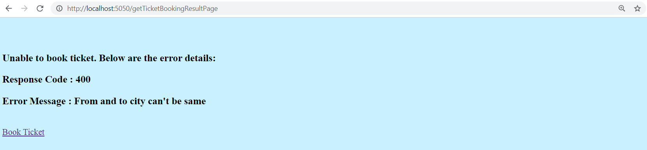

**Screen 7 – Result page showing error message.**

# **Component Naming Conventions**

This is very essential for the auto evaluation framework to identify the mandatory form components in your JSP page. Please follow the ID values as given in the below table while you build the JSP pages. If you would want to define additional components in the JSP pages to add more value, you can give your own ID values.

|  |  |  |  |
| --- | --- | --- | --- |
| **JSP Page** | **Component** | **Component Type** | **ID** |
| ticketBooking.jsp | H1 | Heading | heading |
|  | Form | Form | form (use this as name not ID) |
|  | customerName | Textbox | customerName |
|  | mobileNumber | Textbox | mobileNumber |
|  | fromCity | Dropdown | fromCity |
|  | toCity | Dropdown | toCity |
|  | travelClass | Dropdown | travelClass |
|  | noOfTickets | Textbox | noOfTickets |
|  | Button | submit | submit(id), Book(value) |
| ticketBookingResult.jsp | H3 | Heading | ticket |
|  | A | Anchor Tag | bookTicket(id) |
| trainNotAvailable.jsp | H3 | Heading | noResult |
|  | A | Anchor Tag | bookTicket(id) |
| Error.jsp | Form | Form | error (id) |
|  | H3 | H3 | --- |
|  | H3 | H3 | --- |
|  | H3 | H3 | --- |
|  | A | Anchor Tag | bookTicket(id) |

**Values to be returned from Controller as Model Attributes, and to be used while rendering the JSP. These values must not be hard coded.**

|  |  |  |
| --- | --- | --- |
| **JSP Page** | **Dropdown/Radio button Name** | **Values** |
| ticketBooking.jsp | fromCity  Dropdown | Chennai  Delhi  Bangalore  Pune |

|  |  |  |
| --- | --- | --- |
| **JSP Page** | **Dropdown/Radio button Name** | **Values** |
| ticketBooking.jsp | toCity  Dropdown | Chennai  Delhi  Bangalore  Pune |

|  |  |  |
| --- | --- | --- |
| **JSP Page** | **Dropdown/Radio button Name** | **Values** |
| ticketBooking.jsp | travelClass  Dropdown | AC First Class (1A)  AC 2 Tier (2A)  AC 3 Tier (3A)  Sleeper (SL)  Second Sitting (2S) |